1ST UNIT TEST
SUBJECT : SOCIAL STUDIES MARKS : 20 STD : 8TH DURATION : 1 HOUR

HISTORY
Q1.Rewrite the statements by choosing the appropriate options.(4)
(1) Among the historical sources ………………………………… sources are based on Modern technology.
(a) Written (b) Oral (c) Material (d) Audio-visual
(2) In 1453 the city of ………………………………… was conquered by Ottoman Turks.
(a) Venice (b) Constantinople (c) Rome (d) Paris
(3) The Industrial Revolution began in ………………………………….…… .
(a) England (b) France (c) Italy (d) Portugal
(4) …………… tried to put restrictions on the illegal trade of British.
(a) Siraj-ud-Daulah (b) Mir Kasim (c) Mir Jafar (d) Shah Alam
Q2. COMPLETE THE FOLLOWING diagram. (4)

Q3. ANSWER THE FOLLOWING.(2)
1.Write short note. – Photographs
CIVICS
Q4. Choose the correct option and rewrite the statements. (1)
1.Sometimes, when no party gets a clear majority, ……… government is formed.
(a) Presidential
(b) coalition
(c) Military
(d) communist
Q5.Complete the information in the following table. (1)
Name of the Institution - Functions
……………………………………… - The first and foremost function of the judiciary is to give justice to the people, whenever they may approach it.
Q.6 SOLVE THE FOLLOWING.(4)
1.Answer the following in 25 to 30 words. -- What is a responsible government?
GEOGRAPHY
Q 7. Complete the sentence by selecting the correct option. (2)
A) There are ………………………………….………………..…. time zones in the world.
(a) 360
(b) 24
(c) 100
(d) 365
B) Indian Standard Time is ……………………………….…..
(a) ahead of Greenwich Mean Time by 5 hours 30 minutes
(b) ahead of Greenwich Mean Time by 3 hours 50 minutes
(c) behind Greenwich Mean Time by 5 hours 30 minutes
(d) behind Greenwich Mean Time by 3 hours 50 minutes
Q.5. Write the situation of place A shown in these diagrams in the boxes below them.(2)
(i) Sunrise
(ii) Midnight
(iii) Noon
(iv) Sunset
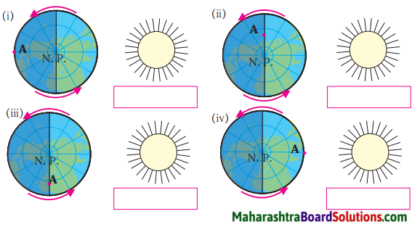
Q5. SOLVE THE FOLLOWING.(2)
1.Give geographical reasons --The local time is decided by noon time.

