1ST UNIT TEST
SUBJECT : MATHS MARKS : 20 STD : 8TH DURATION : 1HR

Q1) FILL IN THE BLANKS.(6)
- Cube of square root of 225 = ............................
- 8⁰ =…………………………………….
- 6¹ =…………………………………….
- The numbers of the form are called ………………………. numbers
- Each pair of corresponding angles formed by two parallel lines and their transversal is of …………………… angles.
- Each pair of interior angles formed by two parallel lines and their transversal is of …………………………. angles.
Q.2 SOLVE THE FOLLOWING EXAMPLES. (8)
1) Compare the following numbers.
$\frac{7}{5}$ , $\frac{13}{7}$
2) Express the following numbers in index form.
i. Fifth root of 13
ii. Sixth root of 9
3) Write the following numbers in the form of rational indices.
i. Square root of 6th power of 129
ii. Cube of 9th root of 34
4) Find the cube root of the following number.
64
Q.3 SOLVE THE FOLLOWING EXAMPLES. (6) (ANY 3)
A) Show the following numbers on a number line. Draw a separate number line.
$$\frac{3}{5}$$
B) Show the number √5 on the number line.
C) In the given figure, each angle is shown by a letter. write all pairs of corresponding angles.
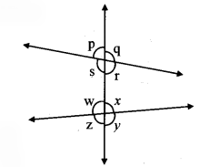
D) Draw a line m. Draw a line n which is parallel to line m at a distance of 4 cm from it.

