REVISION:1st semester exam : std 8th : sub-social studies
HISTORY
Q1. Rewrite the statements by choosing the appropriate options.(4)
(i) The .................. is a museum in Pune which gives information about the history of Mahatma Gandhi.
(a) Aga Khan Palace (b) Sabarmati Ashram (c) Cellular Jail (d) Lakshmi Vilas Palace
(ii) .................. tried to put restrictions on the illegal trade of the British.
(a) Siraj-ud-Daulah (b) Mir Kasim (c) Mir Jafar (d) Shah Alam
(iii) The Anglo-Mohammedan Oriental College was established by ...................... .
(a) Mir Kasim (b) Shah Alam (c) Sir Sayyad Ahmad Khan (d) Mir Jafar
(iv) In 1802, Peshwa ..................... signed the Subsidiary Alliance with the British.
(a) Bajirao I (b) Sawai Madhavrao (c) Peshwa Nanasaheb (d) Bajirao II
Q2. Complete the following table.(4)
Name of the Social Reformer | Organisation
Raja Ram Mohan Roy
 | Satyashodhak Samaj
Swami Dayanand Saraswati
 | Ramkrishna Mission
Q3. Read the passage and answer the following questions (4)
All Indian leaders who were politically aware kept aside their differences of caste, religion, language, province and gathered on a single platform of the Indian National Congress. There were unanimous decisions regarding the objectives of the Congress and taking forward the movement by constitutional means, but there were differences regarding the working system. These were ideological differences. From these differences two main political groups were formed. The Moderates who advocated Peaceful and constitutional means and the Extremists who believed in a severe struggle for the attainment of freedom. Lala Lajpat Rai, Bal Gangadhar Tilak and Bipin Chandra Pal were the extremist leaders.
(a) Who gathered together to form the Indian National Congress?
(b) Which two political groups were formed within the Indian National Congress?
(c) Name the three extremists leaders.
Q4. State True or False. (4)
(i) Dr. Bhau Daji Lad - Indian Scholars
(ii) Dr. R.G. Bhandharkar - Study of Indian culture
(iii) Allan Hume - Establishment of Indian National Congress
(iv) Gopal Krishna Gokhale - Asiatic society
Q5.Do as directed.(6)
1) Write the short note : Reforms for women by Savitribai Phule.
2) Explain the statements with reasons : The Indian sepoys could not keep up with in the British army.
3) Answer the following in brief : Write down the consequences of the struggle of 1857.
CIVICS
Q6. Complete the following sentences by choosing the correct option. (4)
(i)The ex-officio chairman of the Rajya Sabha is the .................. .
(a) President (b) Vice President (c) Prime Minister (d) Chief Justice
(ii) Parliamentary system of government developed in ................... .
(a) England (b) France (c) United States of America (d) Nepal
(iii) The Council of Ministers is led by the .................... .
(a) Party Chief (b) Prime Minister (c) President (d) Speaker
(iv) In India, the executive power is vested in the .................... .
(a) President (b) Prime Minister (c) Speaker (d) Chief Minister
Q7. Match the pairs. (4)
‘A’ Column | Answer
1. Cirrus | d. Snowflake clouds
2. Cumulonimbus | a. Roaring clouds
3. Nimbostratus | c. Continuous rainfall
4. Alto-cumulus | b. Floating clouds

Q8. Explain the following statement with reasons. (2)
The president is not the supreme Head of State.
Q9. write the following concept in your own words. (2)
Jumbo Ministry
GEOGRAPHY
Q10. Complete the sentence by selecting the correct option. (4)
1. Which one of the following options is related to marine deposits?
(c) Volcanic ash, lava, fine particles of soil.
2. Which seismic waves can travel can through liquid medium?
(a) Primary waves
3.The difference between the local time of any two consecutive longitude is ................
(b) 04 minutes
4. Which of the following occurs in the area where the cold and warm currents meet?
(d) Thick fog
5. Which factor out of the following does not affect the region along the coast?
(c) Land breeze
6.Which of these following currents flow from the northern polar regiorTup to Antarctica?
(d) Deep ocean currents
7.The ………….. of the air is dependent on the temperature of the air.
vapour-holding capacity
8. The amount of vapour in 1 cu.m, of air shows the ………….
absolute humidity
Q11. Match the column. (4)
‘A’ Column | ANSWER
1. Cirrus | Snowflake clouds
2. Cumulonimbus | Roaring clouds
3. Nimbostratus | Continuous rainfall
4. Alto-cumulus | Floating clouds
5. Sial | Silica and Aluminium
6. Sima | Silica and Magnesium
7. Inner core | Nickel and Iron

Q12. True or False. (4)
1. The core of the earths’ crust is made up of hard rock. : FALSE
2. Ocean currents give specific directions and velocity to the water. : TRUE
3. The density of various materials are not the same in the interior of the earth. - TRUE
4.Generally, surface ocean currents are formed in the equatorial regions. - FALSE
5.Ocean currents hold great importance for human life. -TRUE
6. The movement of ice-bergs is not dangerous for water transport. – FALSE

Q13. Differentiate between: (2)
1. Humidity and Clouds.
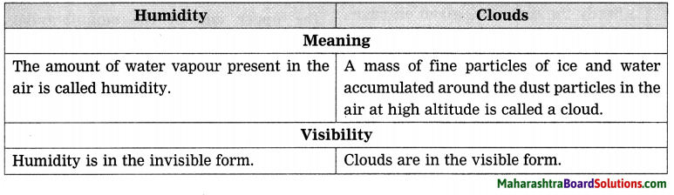
2. Cumulus clouds and Cumulonimbus clouds
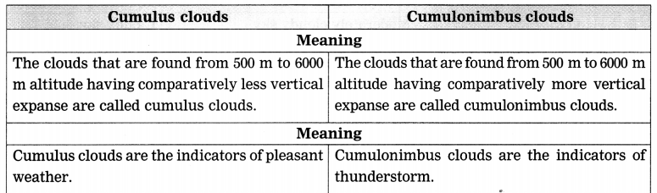
Q14. Give geographical reasons.(2)
1.There is correlation between the density of metals and their location in the interior of the earth.
ANS : Metals with low density are found in upper level in the interior of the earth and the metals with high density are found in the lower level in the interior of the earth. Thus, there is correlation between the density of metals and their location in the interior of the earth.

2. The local time is decided by the noontime.
ANS: During the rotation of the earth, when a particular longitude comes exactly in front of the sun, it is considered as noontime (12 noon) on that longitude. This noontime is considered as local time of that longitude.

