School Name
2ND UNIT TEST : YEAR -
Name : ……………………………………… Date ……………… Roll No.: ………
Class : VIII Div : ……. Subject : SOCIAL STUDIES Marks :20

HISTORY
Q1 Fill in the blanks 2
- ……………. led the Dharasana Satyagraha.
- The nation wide movement of 1942 is also called ……….. .
Q2 Complete the following table 2
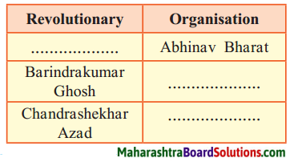
Q3 Explain the following statements with reasons. 2
The Indian National Army had to lay down their arms.
Q4 Answer the following questions in brief: 2
Why did the Indian National Congress withdraw the Civil Disobedience Movement?
CIVICS
Q5 Fill in the blanks 2
- The right to summon the state legislature lies with the …………… .
- The Chief Justice of Supreme Court is appointed by the ……………………
Q6 Complete the following table 2
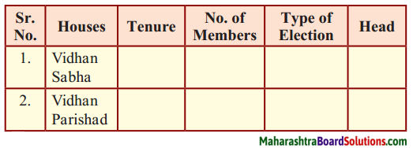
Q7 Write a short note. 2
Criminal Law
GEOGRAPHY
Q8 Fill in the blanks 2
- People of …………… age group are
included in the productive population.
- The spread of modern technology in
society is mostly dependent on …………….. .
Q9 True or False 2
- In rural areas, residential areas occupy large tracts.
- The population density of a region can be understood from its area.
Q10 Give geographical reasons: 2
Population is an important resource.

