School Name:
2nd Semester Exam : YEAR -
Name : ………………………………………………………………… Date ……………… Roll No.: ………… Class : VIII Div : ……. Subject : Mathematics Marks :50
____________________________________________________________________
Q.1 Fill in the blanks.(5)
( circular , volume , area , mean , arcs , space , triangular , compound , face )
- The average is called …………………….. in statistical language.
- Solid figures occupy some ……………………………….
- The chords corresponding to congruent ………………….are congruent.
- Base of a cylinder is ......……………….
- ……………………. of a cuboid = l X b X h
Q.2 Match the pairs. (5)
GROUP A | ANSWER | GROUP B
ㄫ |  | 2 litre | t=1
2000 cc |  | t=11 | 1 litre
t – 8 = 3 |  | 22/7 | t= (–11)
9 + t = 10 |  | 7/22 | t=(–1)
21t² / 3t |  | 7t | 3t
Q.3 Write the formula for the following. (5)
1: Area of circle = | 2: Volume of cylinder =
3: Volume of cube = | 4: Area of triangle =
5: Volume of a cuboid =

Q.4 Solve the following. (15)
- Divide. Write the quotient and the remainder. (a² + 7a- 5) ➗ (a + 3)

- Solve the following equation.
- 4 + 9b = 6b + 29

- State the test and the one to one correspondence of vertices by which the triangles are congruent.  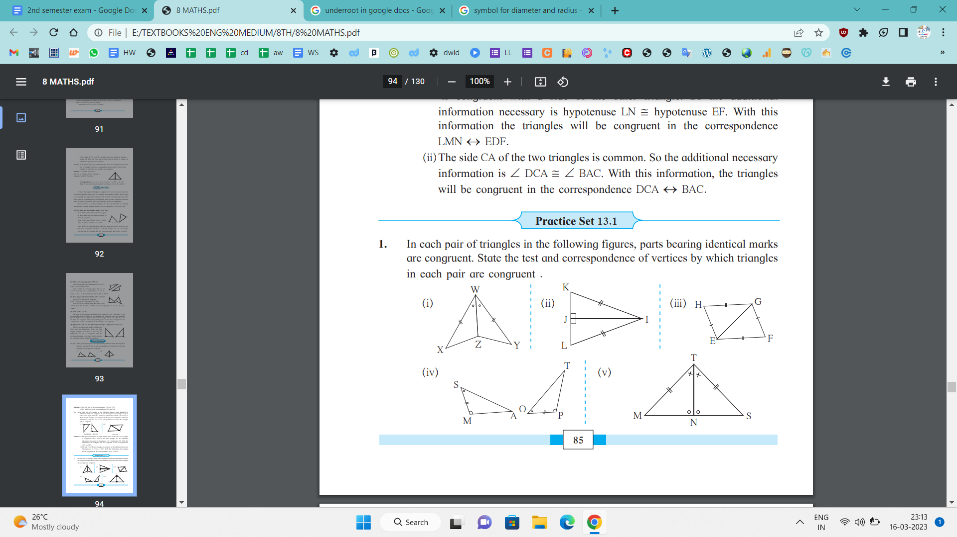 | - Write no of faces, vertices & edges of given shape & verify Euler’s Formula.  
  Faces - | Vertices - | Edges -
- If the base of a parallelogram is 18 m and its height is 11 m, find its area.

Q.5 Solve the following. (20)
- Find the volume of a box if its length, breadth and height are 20 cm, 10.5 cm and 8 cm respectively. | - Find the curved surface area of the cylinder. r = 7 cm, h = 10 cm
- N is the centre of the circle whose radius is 10 cm. Find the distance of the chord from the centre if the length of the chord is 12 cm. | - Find the number of years for which the compound interest of ₹9000 is ₹1890, at the rate of 10 p.c.p.a
- Observe the following graph and answer the questions.
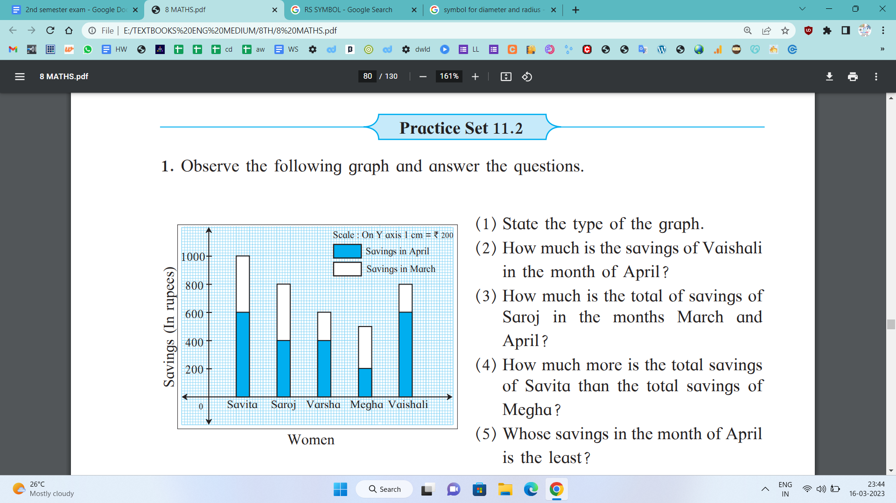

- How much is the savings of Vaishali in the month of April? ………………..
- How much is the total savings of Saroj in the months March and April?...........................................................................
- How much more is the total savings of Savita than the total savings of Megha?..........................................................
- Whose savings in the month of April is the least? ………………………………

