प्रथम सत्र परीक्षा
नाम : …………………………………………………………………………………………………… अनुक्रमांक: ………………….
कक्षा : आठवी तुकडी : अ / ब विषय : हिंदी अंक: ५०
SCHOOL NAME :
____________________________________________________________________________________________
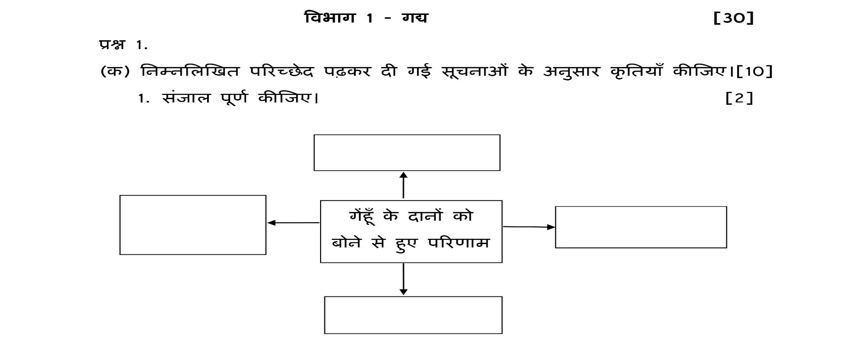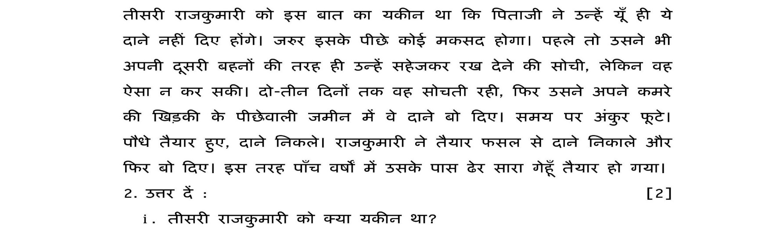__________________________________________________________________________________________________________________________________________________________________________________________________________
(6)
(12)
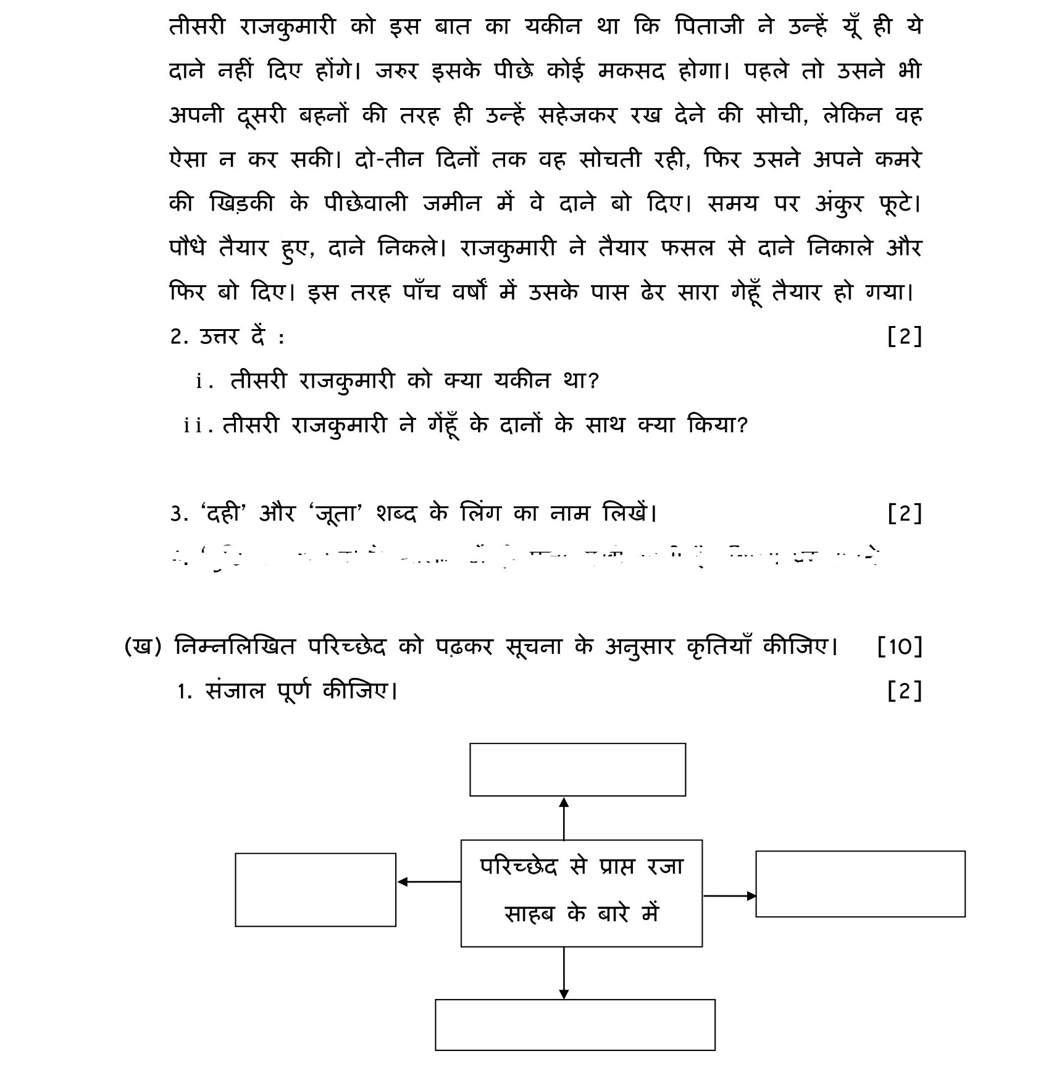__________________________________________________________________________________________________________________________________________________________________________________________________________
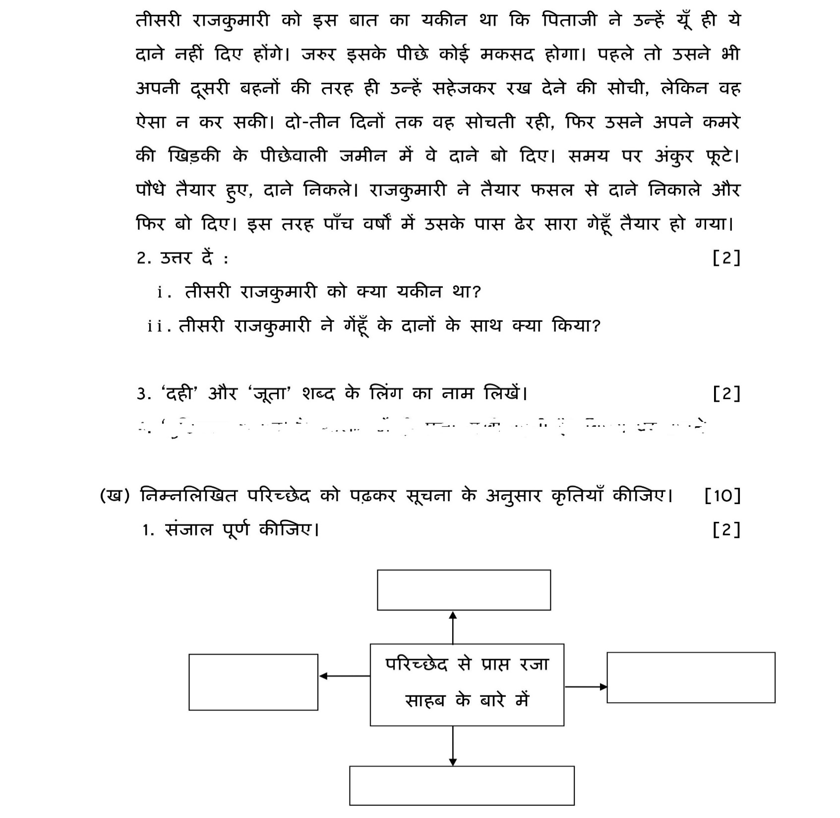_____________________________________________________________________________________________________
(6)

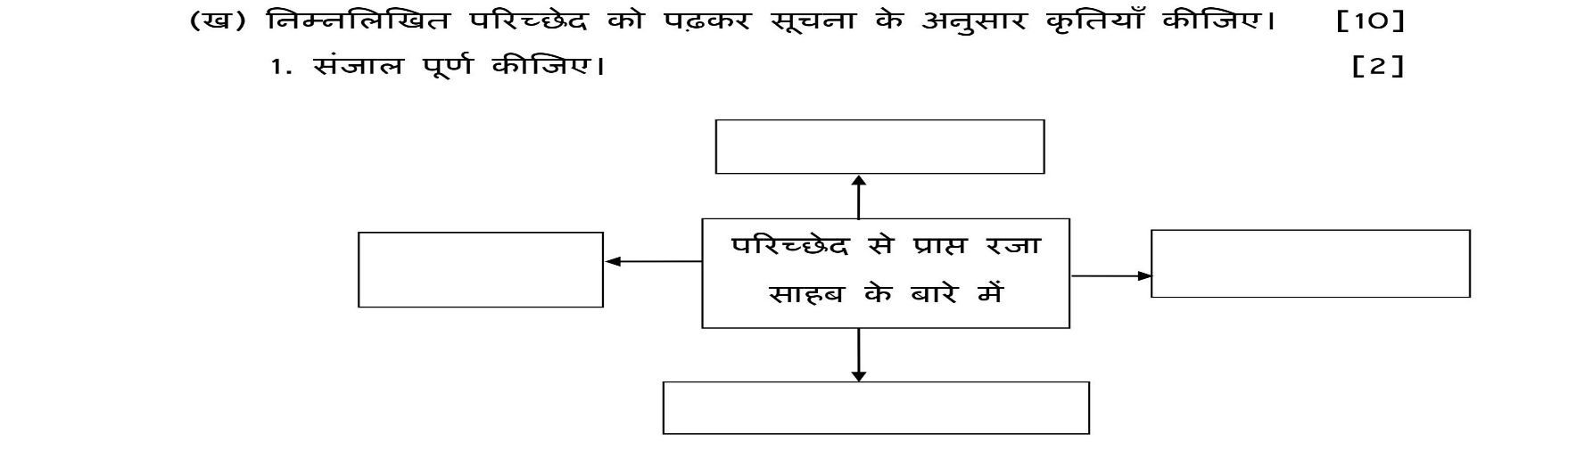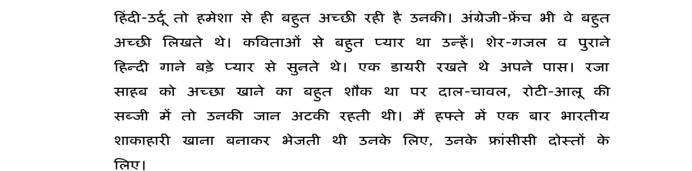

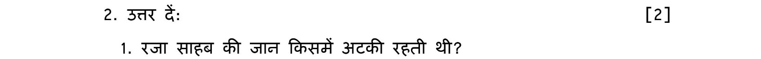
__________________________________________________________________________________________________________________________________________________________________________________________________________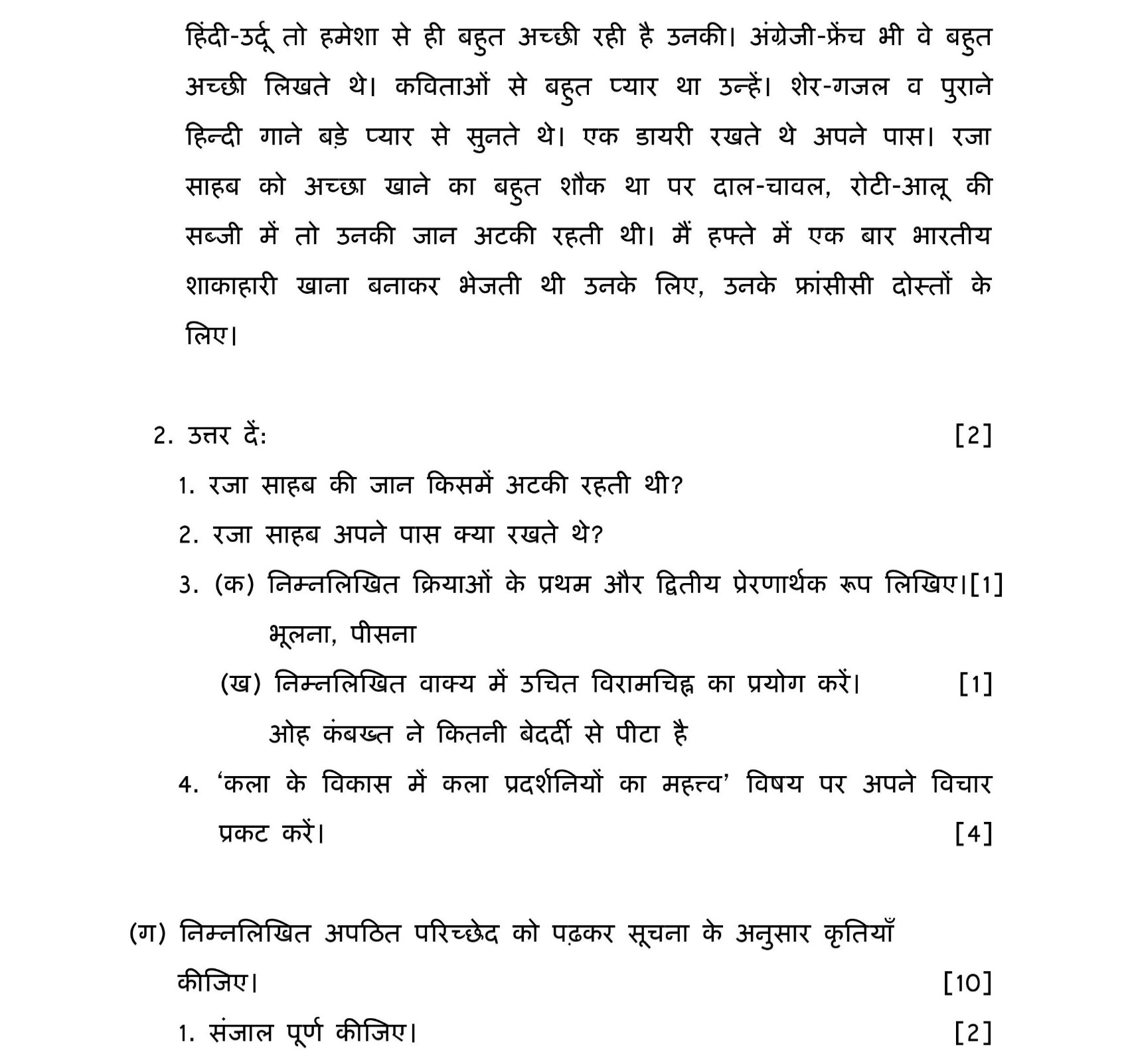__________________________________________________________________________________________________________________________________________________________________________________________________________
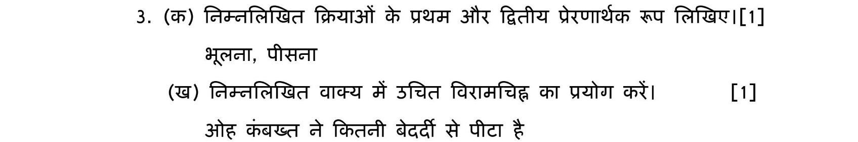_____________________________________________________________________________________________________

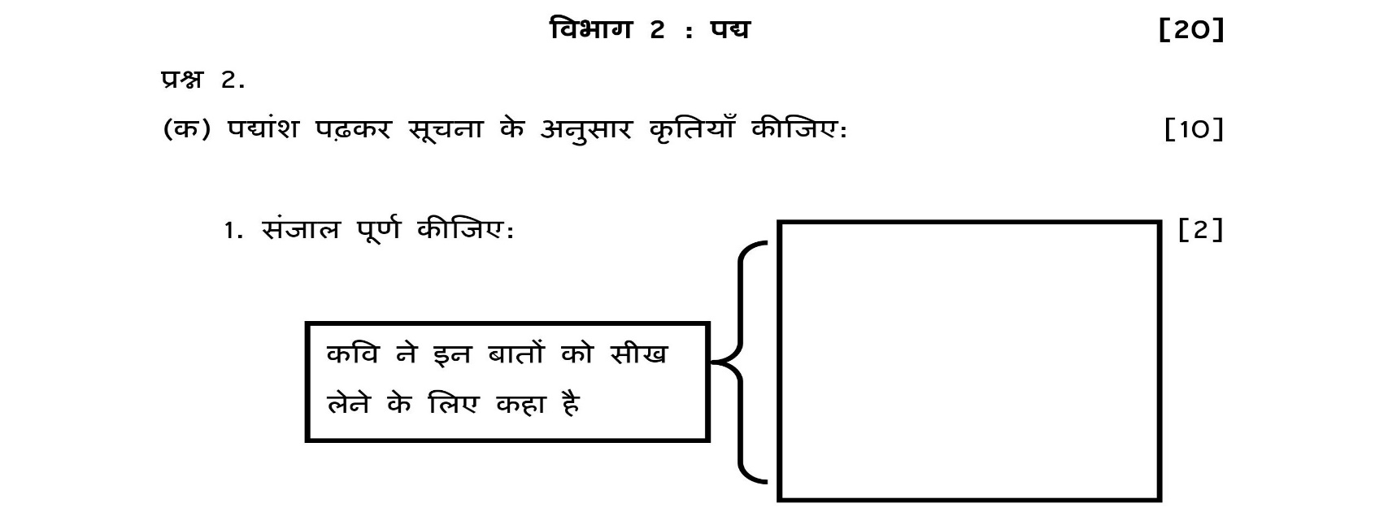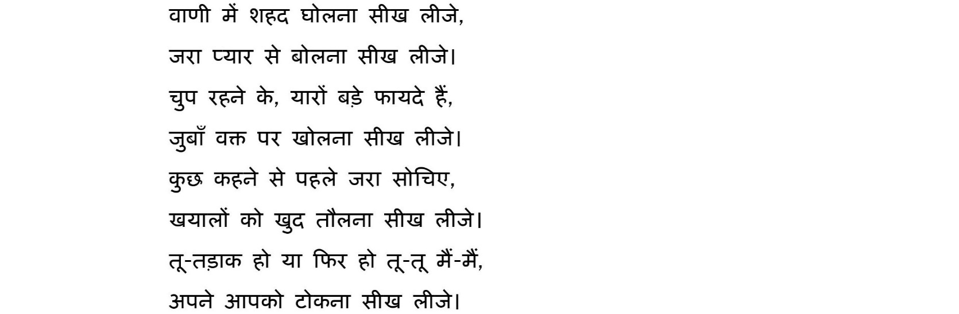
06
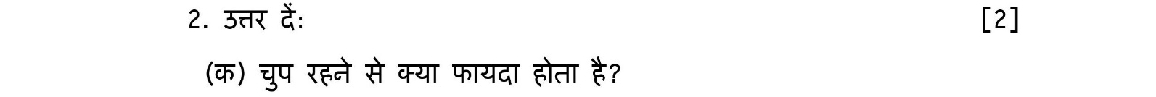
__________________________________________________________________________________________________________________________________________________________________________________________________________
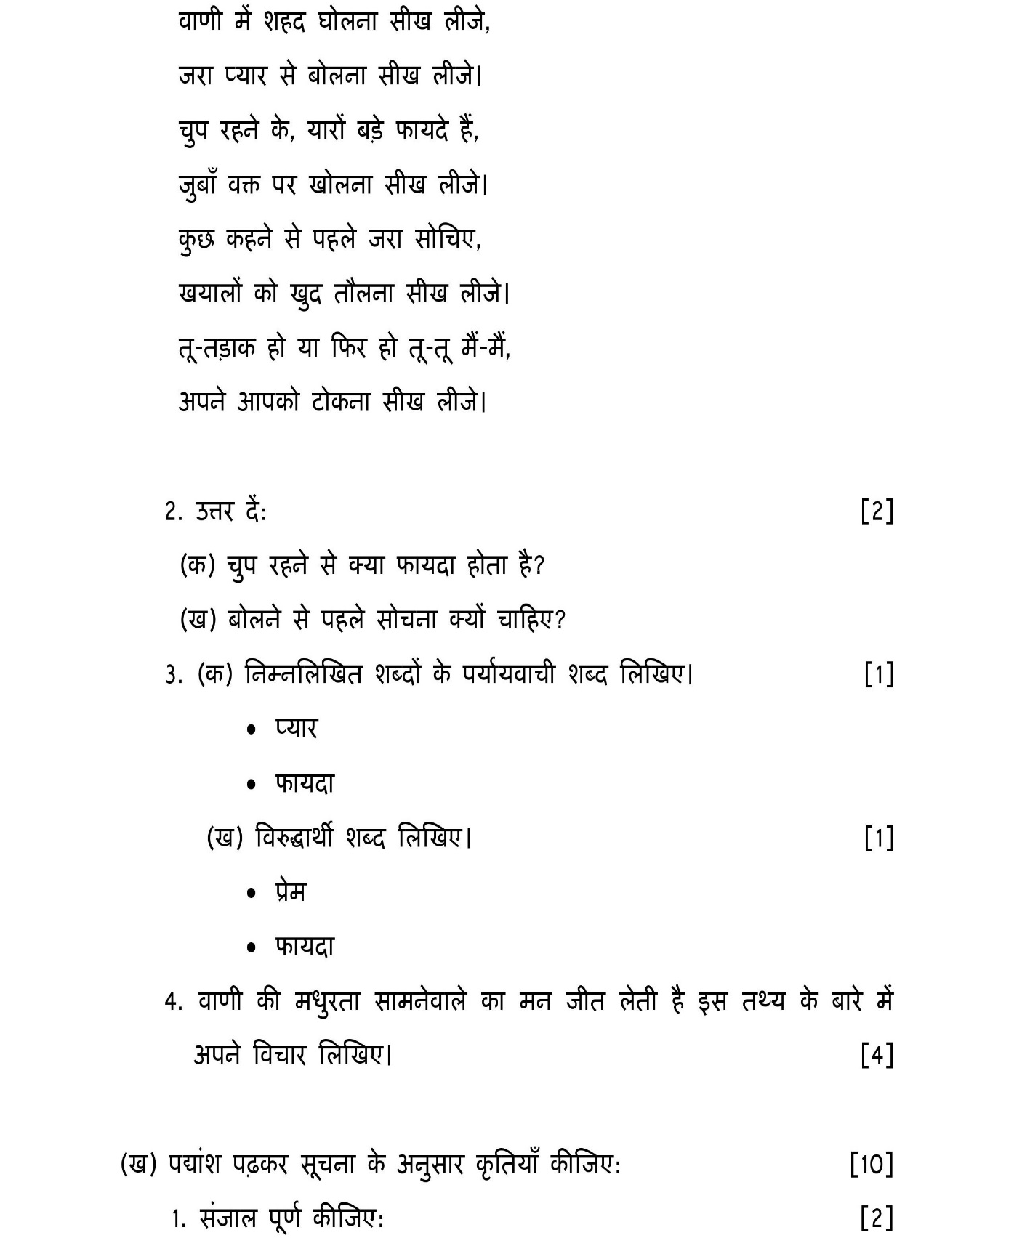__________________________________________________________________________________________________________________________________________________________________________________________________________
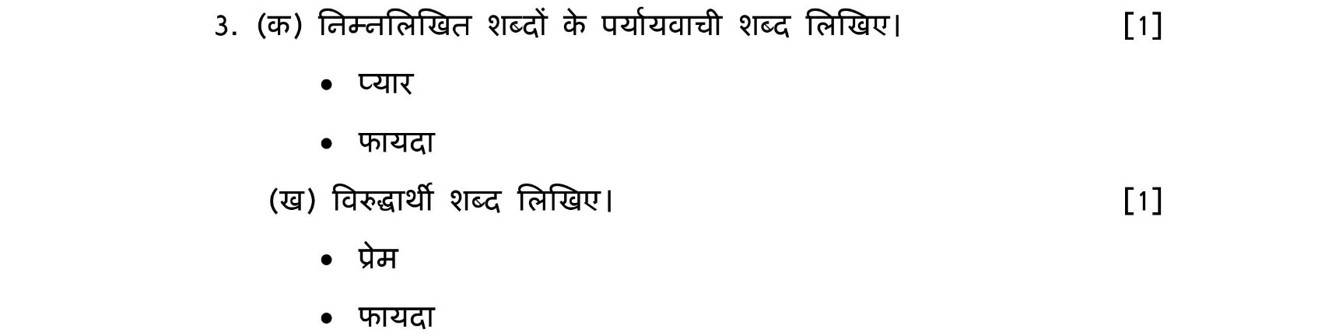

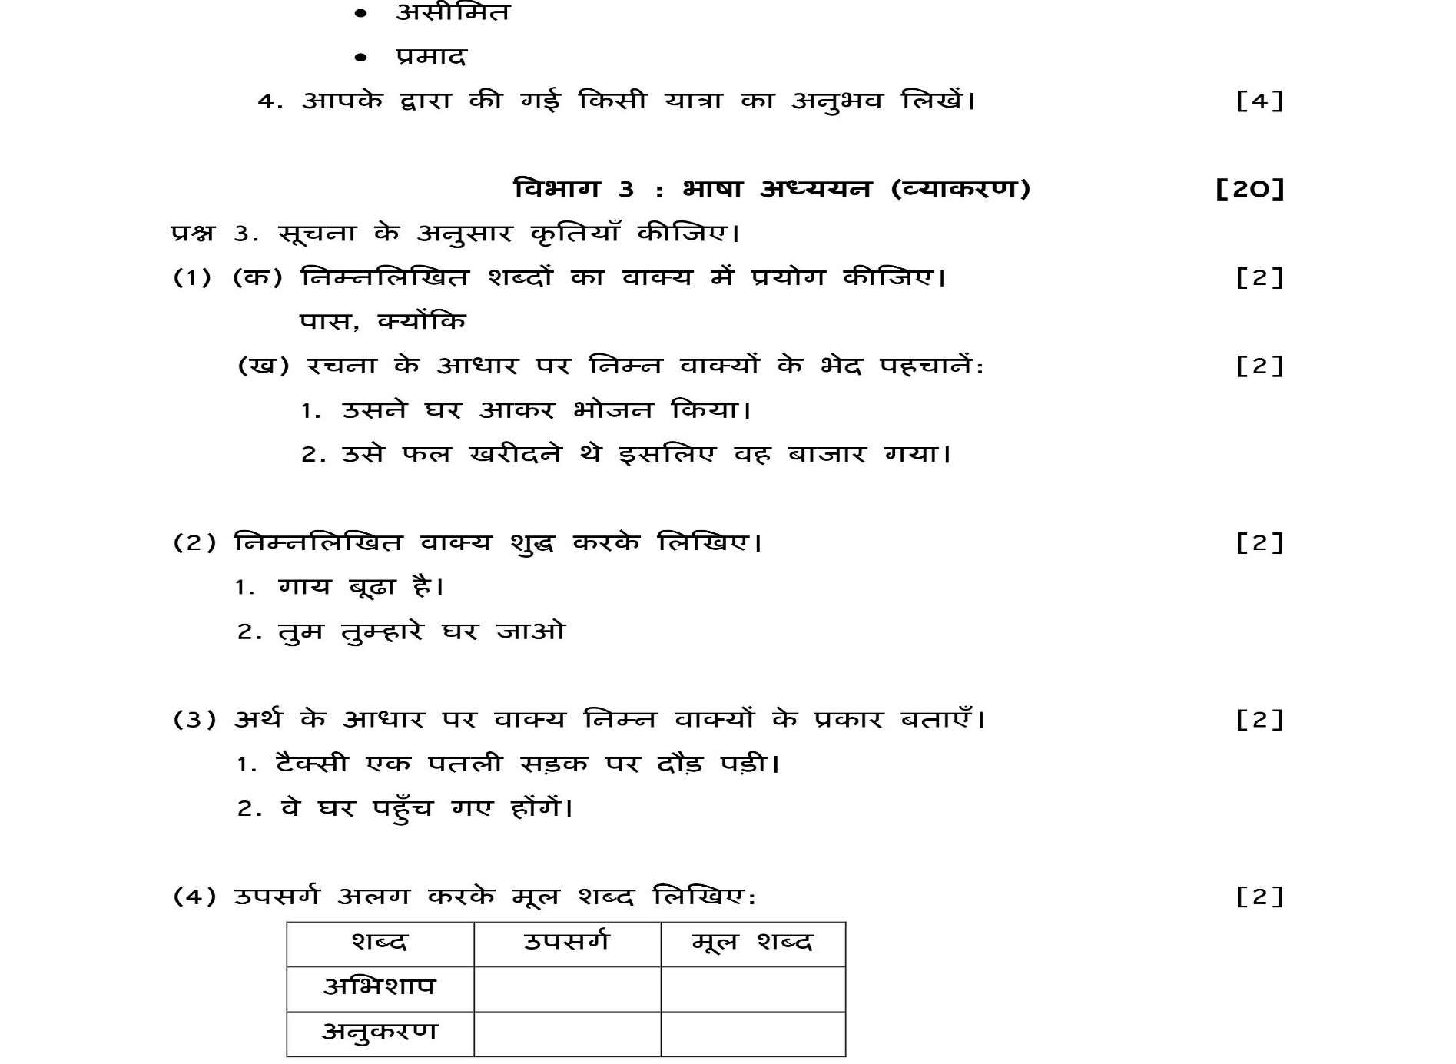__________________________________________________________________________________________________________________________________________________________________________________________________________________________________________________________________________________________________________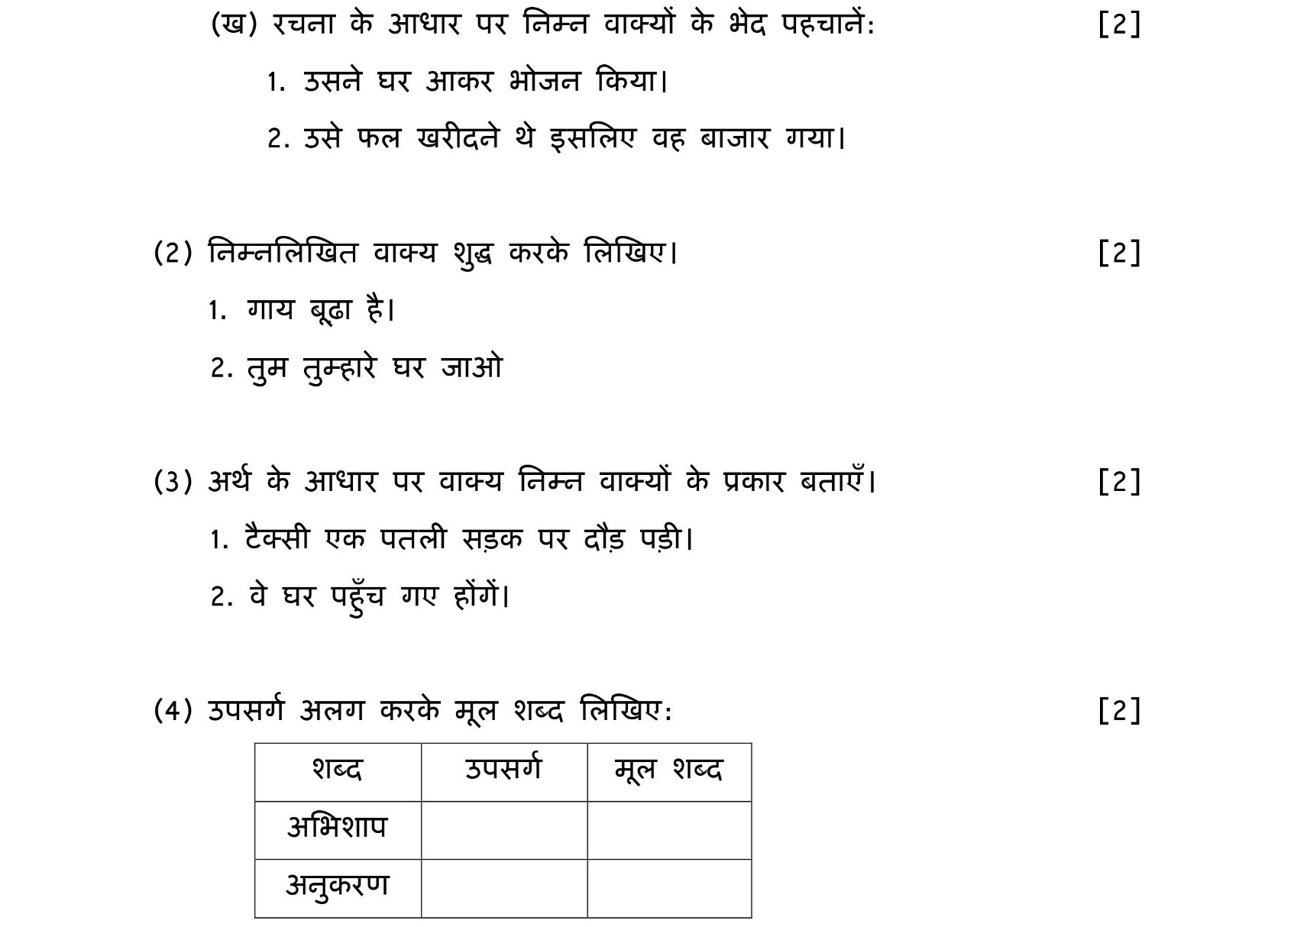
12
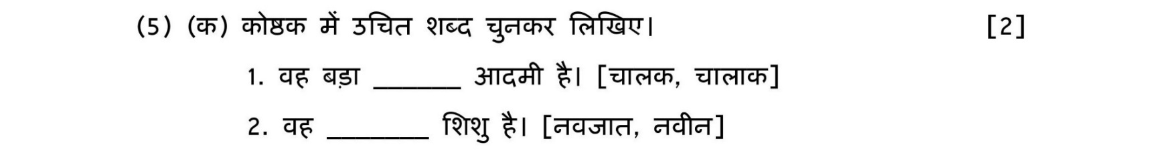
(20)
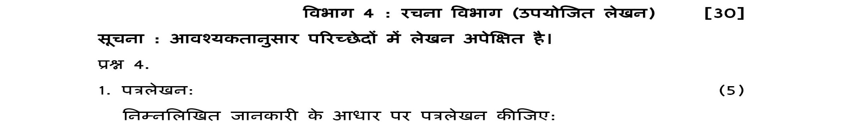
20
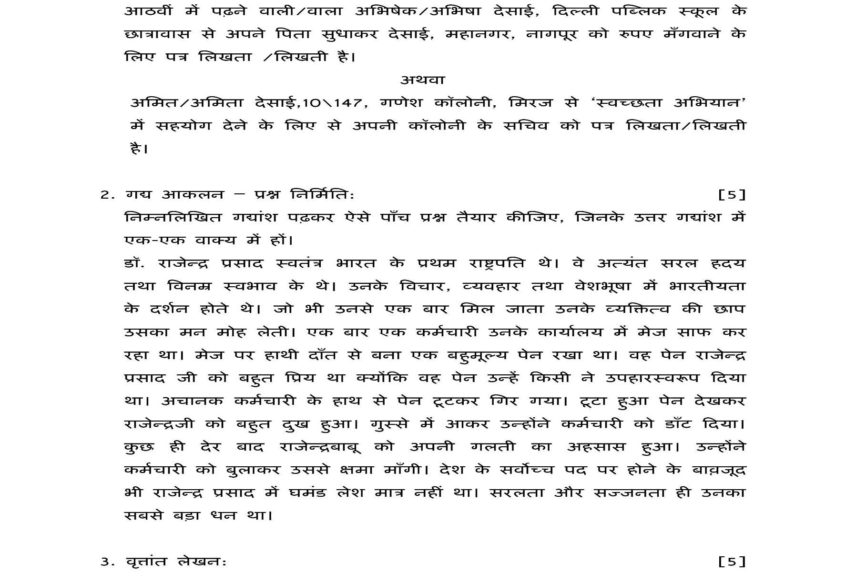

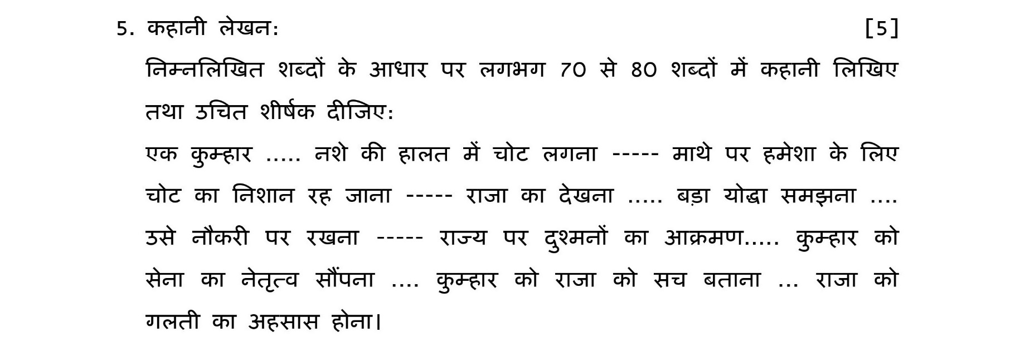
2

3.
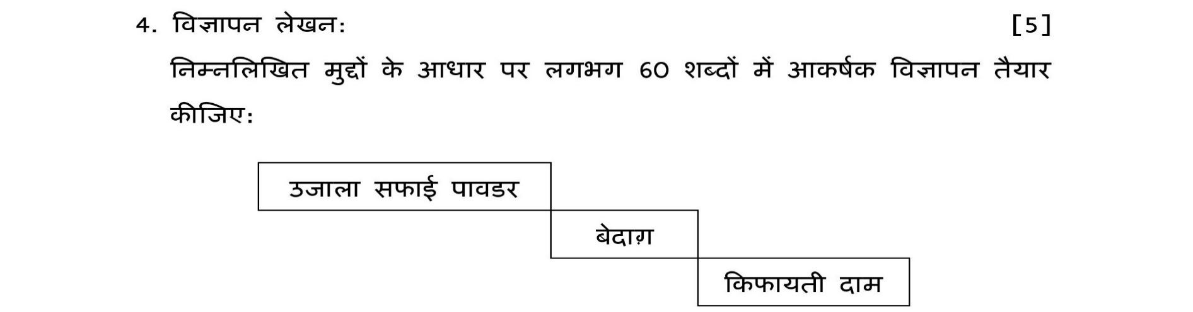

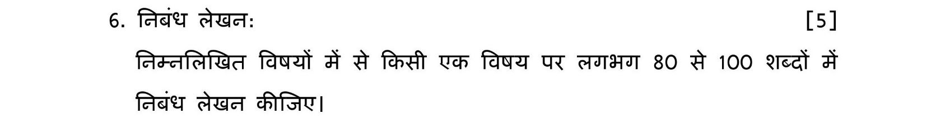
4.
- सत्संगति 2) समय का सदुपयोग

